**Task 1**

1. #include <stdio.h>
2. int main() {
3. int age;
5. printf("Enter your age:");
6. scanf("%d", &age);
7. if(age>=18)
8. {printf("voter is eligible.");}
9. else
10. {printf("voter is not eligible");
11. }
12. return 0;
13. }

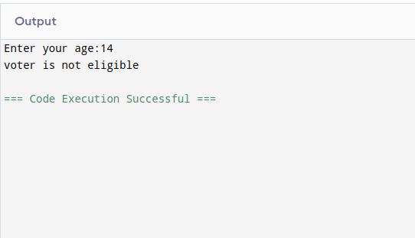

**TASK 2**

1. #include <stdio.h>
2. int main() {
3. int num;
4. int num2;
6. printf("Enter your number:");
7. scanf("%d", &num);
8. num2=num%2;
10. if(num2==0)
11. {printf("the number is even.");}
12. else
13. {printf("the number is odd.");
14. }
15. return 0;
16. }

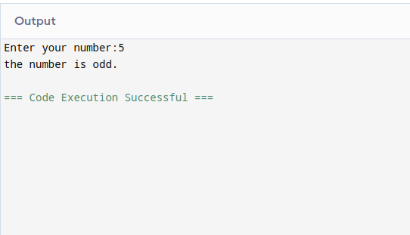

**TASK 3**

1. #include <stdio.h>
2. int main() {
3. int num1, num2, num3;

6. printf("Enter your number1: ");
7. scanf("%d", &num1);
8. printf("Enter your number2: ");
9. scanf("%d", &num2);
10. printf("Enter your number3: ");
11. scanf("%d", &num3);
12. if(num1>num2 && num1>num3)
13. {printf("Number1 is greatest in all.");}
14. else if(num2>num1 && num2>num3)
15. {printf("Number2 is greatest in all.");}
16. else
17. {printf("Number3 is greatest in all.");}
18. return 0;
19. }

